**Seating Chart App Instruction Guide**

**Created by** [**Rohith Venkatesh**](https://www.linkedin.com/in/rohithvenkatesh/)

**rvenkatesh2025@g.ucla.edu**

***Note: App can only be run on Windows***

1. Please read the End-User License Agreement (EULA) and understand its contents.

1. Open the Seating_Chart_App.xlsm Excel Workbook
2. Make sure to “Enable Editing” at the top of the page

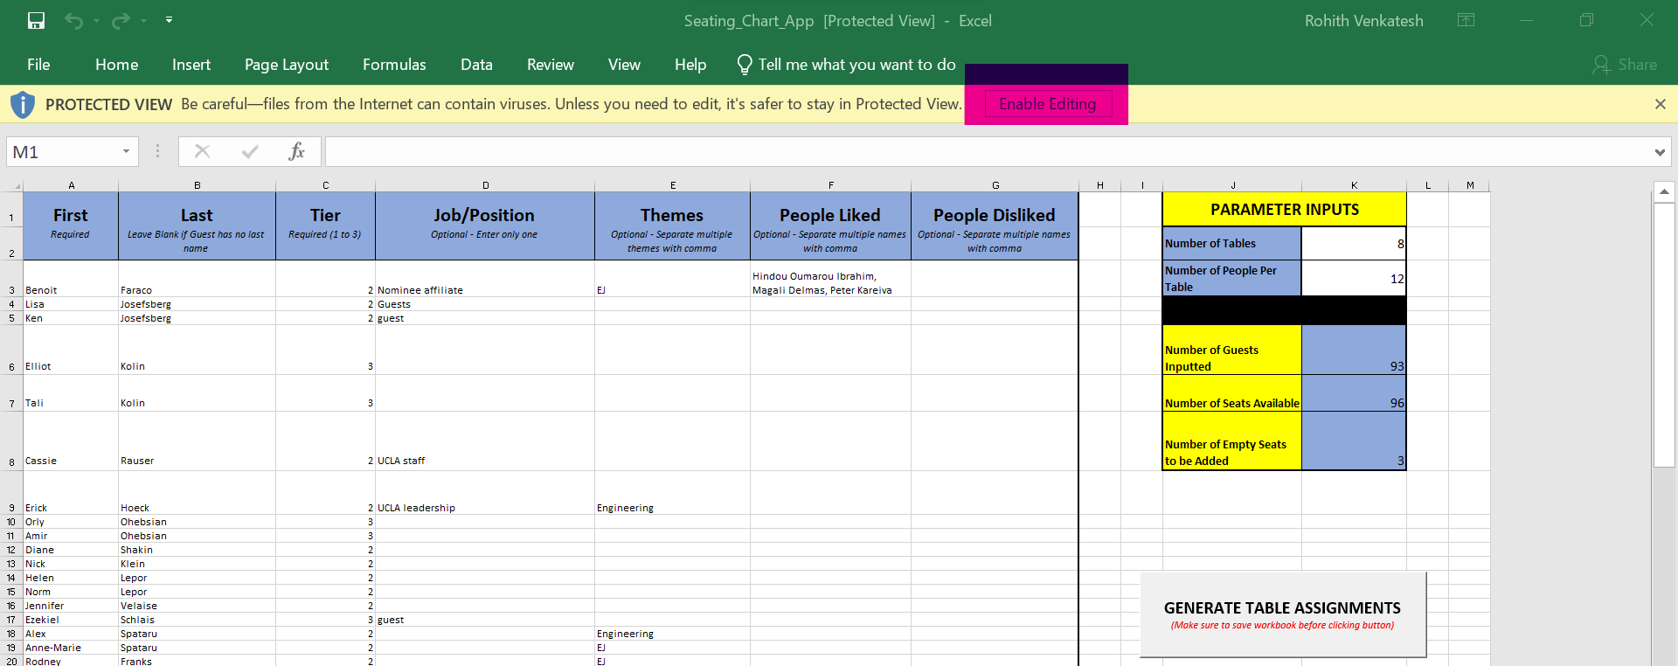

1. Make sure to “Enable Content” at the top of the page

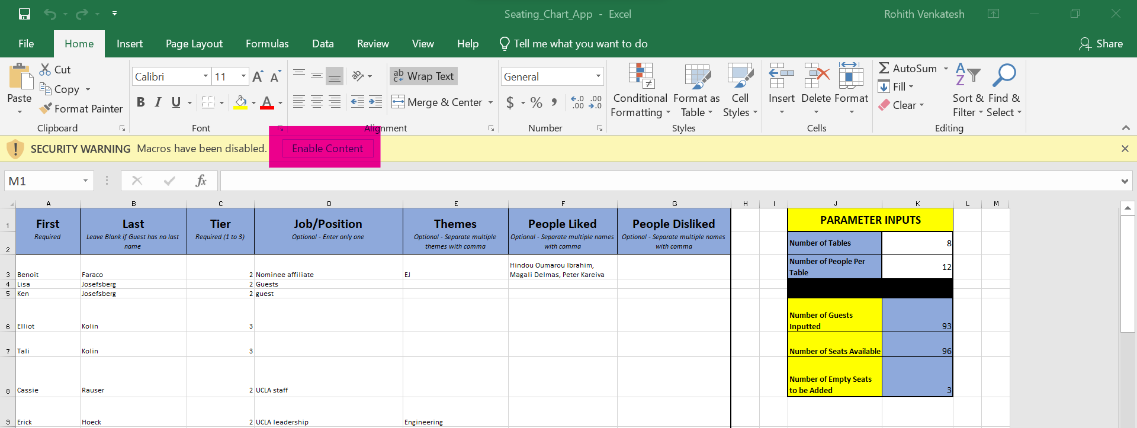

1. Input all necessary Guest data in columns A through G. Look at the Column labels on instructions on how to properly input data.
   1. The “First” and “Last” columns allow the user to input the guest’s first and last name. The first name column is **REQURIED** while the last name column is optional. The program still works if you want to leave the ‘Last Name” Column blank and input the guest’s full name in the first name column.
   2. The “TIER” column ranks all the guests by tiers (1 to 3). Tier 1 guests are the highest priority while Tier 3 guests are lowest priority. Higher priority guests are accounted for first when making seating arrangements, so higher priority guests are more likely to be seated next to their preferred tablemates and away from people marked to be seated away from. This column is **REQUIRED**.
   3. The “Job/Position” column allows the user to input the guest’s Job/Position. The program will try to distribute guests with the same job between different tables to ensure that there is job diversity at every table. This column is optional.
   4. The “Themes” column allows the user to unput any themes that may be associated with the particular guest (i.e. Water conservation, Wildfire research, Air pollution, etc.). The program will seat guests with common themes at the same table. This column is optional.
   5. The program will try to seat the guest alongside the people in the “People to Seat at Same Table” field and away from the “People to Seat at Different Table” field. These columns are optional.
      1. Make sure to input the full, correct names in both fields. The program will disregard any misspelled names when making seating decisions.
   6. When using the seating chart app for catering purposes, the “Preferred Entrée” column allows the user to input entrees associated with each guest (i.e. Vegetarian, Gluten-Free, etc.). This column is optional.
   7. All inputs are case-insensitive. The case of the input data will not affect the program in any way. However, typos will result in a non-desired output.

1. Input the table dimensions in the “TABLE DIMENSION INPUTS” field. Make sure that the parameters for the number of tables and the number of seats per table sum up to at least the number of people in the list. The program will not run if there are fewer available seats then guests inputted. Save data as you keep manipulating the inputs (CTRL + S or pressing the save icon at the top left of the page).
   1. The “TABLE DIMENSION INPUTS” Table on the left allows users to manually input the number of tables and seats per table. Below the input, the user can see the number of guests inputted into the program, along with the number of seats available (based on the table dimension inputs), and the number of empty seats that will have to be added to make the tables even.
   2. The “DISPLAY OPTIONS” Table allows users to toggle what data is displayed on the final seating chart and how any spare seats are distributed. If the user desires the Entrees or Job/Position to be displayed on the seating chart, simply enter a “Y” (upper or lower case) in the in the cell right next to the field description.
   3. The program defaults to adding all empty seats to the last table . If you want the empty seats to be distributed between all the tables, input a “y” (case-insensitive) in the cell next to the field.

1. Make sure all inputs are correct and saved (CTRL + S). Click on the button on the far right marked “GENERATE TABLE ASSIGNMENTS” to generate a new sheet with the corresponding table assignments.

1. The sheet will temporarily close and reopen (it might take a few seconds).
   1. If the Table Dimensions are improper (i.e. there are not enough seats for the number of guests inputted), an error message will appear and the program will terminate prematurely.

1. Once the sheet is reloaded, navigate to the newly created sheet, “Table Assignments”

1. The Guest Names and their corresponding Table Numbers will be shown on the left (along with the Job/Position and Preferred Entrée of each guest if toggled on), and to the right of it, each table will have a visual seating representation (meant for circular tables). To see all the Table Lists and their corresponding visuals, simply scroll down.

* 1. Excel Tools can be used to manipulate the seating arrangements, and change the font/size/title/style of the visual seating charts.
     1. In the example below, the angle of the names was changed so all the names fit into the slots on the doughnut chart (Right Click on Names on Chart -> Format Data Labels -> Size & Properties -> Alignment -> Custom Angle), and the title was changed to reflect the theme of the table. The style was also manually changed to make the chart readable (Chart Design -> Chart Styles).

1. If a change wants to be made to the data input, simple return to the “Guest Input” sheet, make and save all necessary changes, and click the button to generate another sheet of table assignments.

